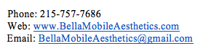
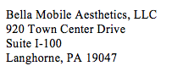
Name: ______________________________________ Mobile Number: __________________

Date of Birth: ________________________________ Email: __________________________

Address: ____________________________________ Referred By: _____________________

____________________________________________

Current or Past Medical Conditions: ________________________________________________

Current Medications: ____________________________________________________________

Allergies: _____________________________________________________________________

Emergency Contact: _____________________________________________________________
Please mark treatments that you might be interested in or have questions about:

Botox/Xeomin | Dermal filler (Juvederm, Radiesse, Belotero, etc)
Microdermabrasion | Micro-Needling
Cavi-Lipo | Medically Supervised weight loss
Chemical Peels | Skin rejuvenation with PRP
Skin Care- BelleDerm Professional Grade | Other

